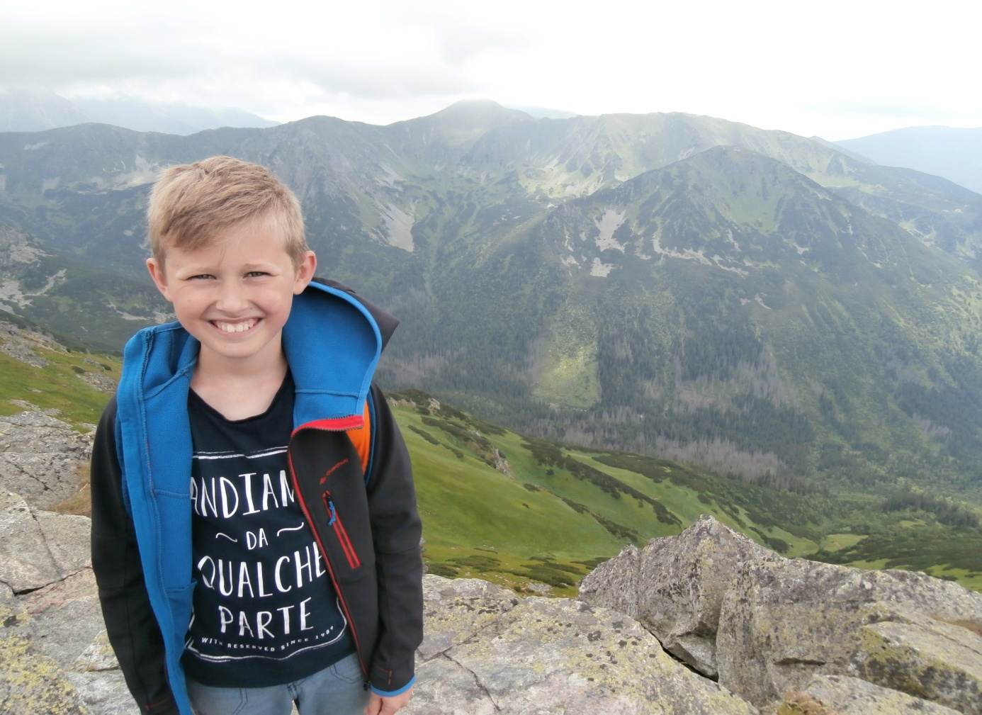
Hello !
My name is Miłosz. My surname is Bojanowski. I’m from Poland. I live in Lubicz near Toruń. I am eleven years old and I go to fifth grade. I go to Tadeusz Kościuszko School. My favorite lessons are English and Science. My mum’s name is Eliza and my dad’s name is Tomek. I like swimming and I attend a swimming club Dolphin. I’m really good at swimming. I also like hiking. My dream is to go to France. Thank you for inviting me.
See you later in France.

Miłosz

