Hello!
My name is Magda. I’m 12. I live with my 2 brothers, my mum and dad. I also have a pet. It’s a chinchilla. Her name is Masza. She’s very fluffy. I love playing with her. She’s so fast, and she jumps very well. I go to a music school. I can play the piano well and I started to learn to play the flute. I would like to play the violin too. I love horses and I often ride them. I also read a lot. I especially like adventure books. I like to draw horses, ponies and people. I’m pretty good at this. I love music.
See you soon!
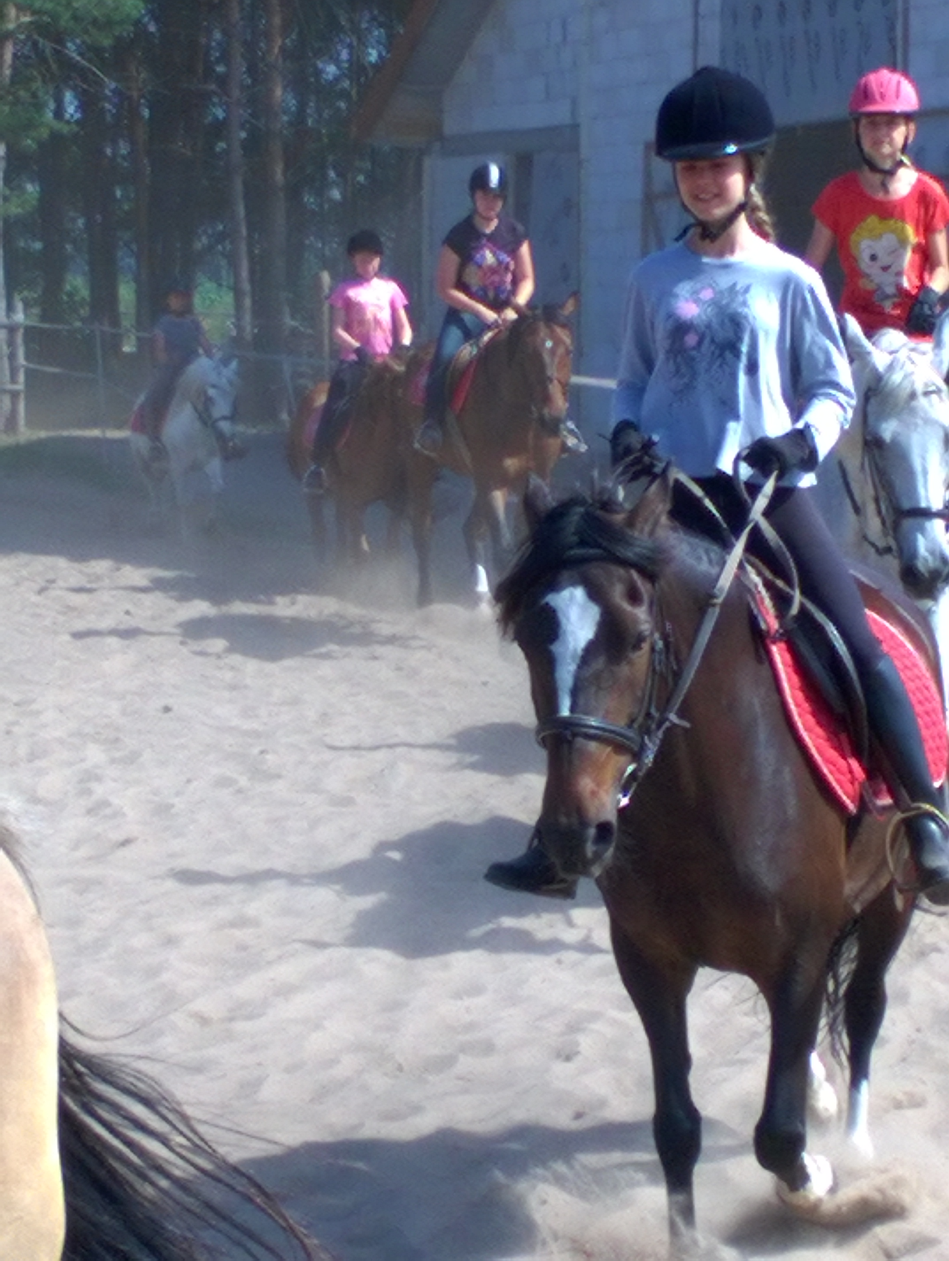
Magda


