TECHNICAL SHEET N°6

Blind goal shot

  - 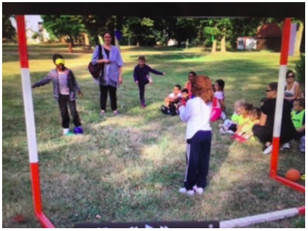

Educational objective: Score a goal with blindfolded eyes and a hearing aid.

Organisation :
- Two teams: a goaltending team and a shooter team.
- A different child at each role (the shooter and his assistant and the goalkeeper) for all shots.

Game rules :
When a player shoots, he has his eyes bandaged and one of his teammates installed behind the cages helps him with a sound signal (whistle). The goalkeeper from the other team has to stop the ball. One point for every successful shot.

Duration of the game : 10 minutes

Equipment
Plots, goal cage, eyebrow, ball, whistle or bell.

