TECHNICAL SHEET N°4

OPPOSITION GAME / KEEPING PRISONERS

  - 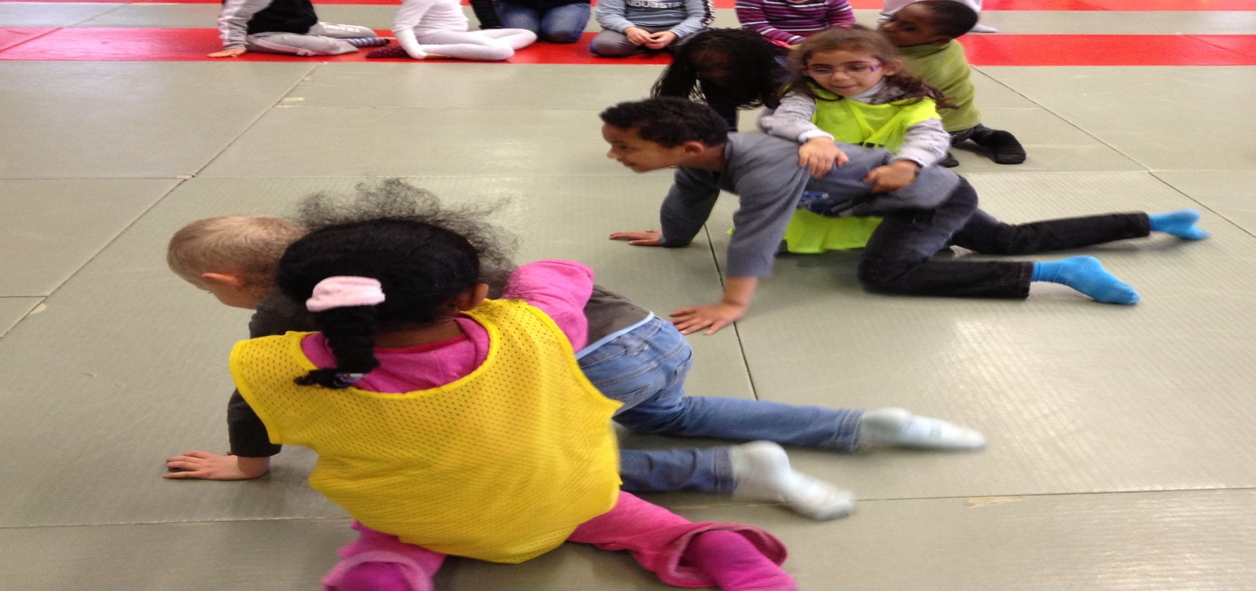

Educational objective: Keep his opponent blocked or succeed in releasing

Organisation : Sports mats grouped together in one space. Round : 30 seconds
- A « Jail » space is delimited .
- Two teams are opposed.
- Childs are attackers « police man » or defenders « prisoner » all along a round.
- Switch roles and opposing teams.

Game rules : At first, the two children are seated in « jail »; The attacker (« police man ») holds the defenders (« prisoner ») by placing himself in his back.
- The «prisoner» has to go out jail and « the police man » as to stop him.
- The « police man » can’t catch his « prisoner » out of « jail ».
- The « police man » who has lost his « prisoner » can not help a partner.

Duration of the game : 10 minutes

Equipment Sports mats, chasubles.

