TECHNICAL SHEET N°3

TCHOUK BALL/PASS AND GO

  - 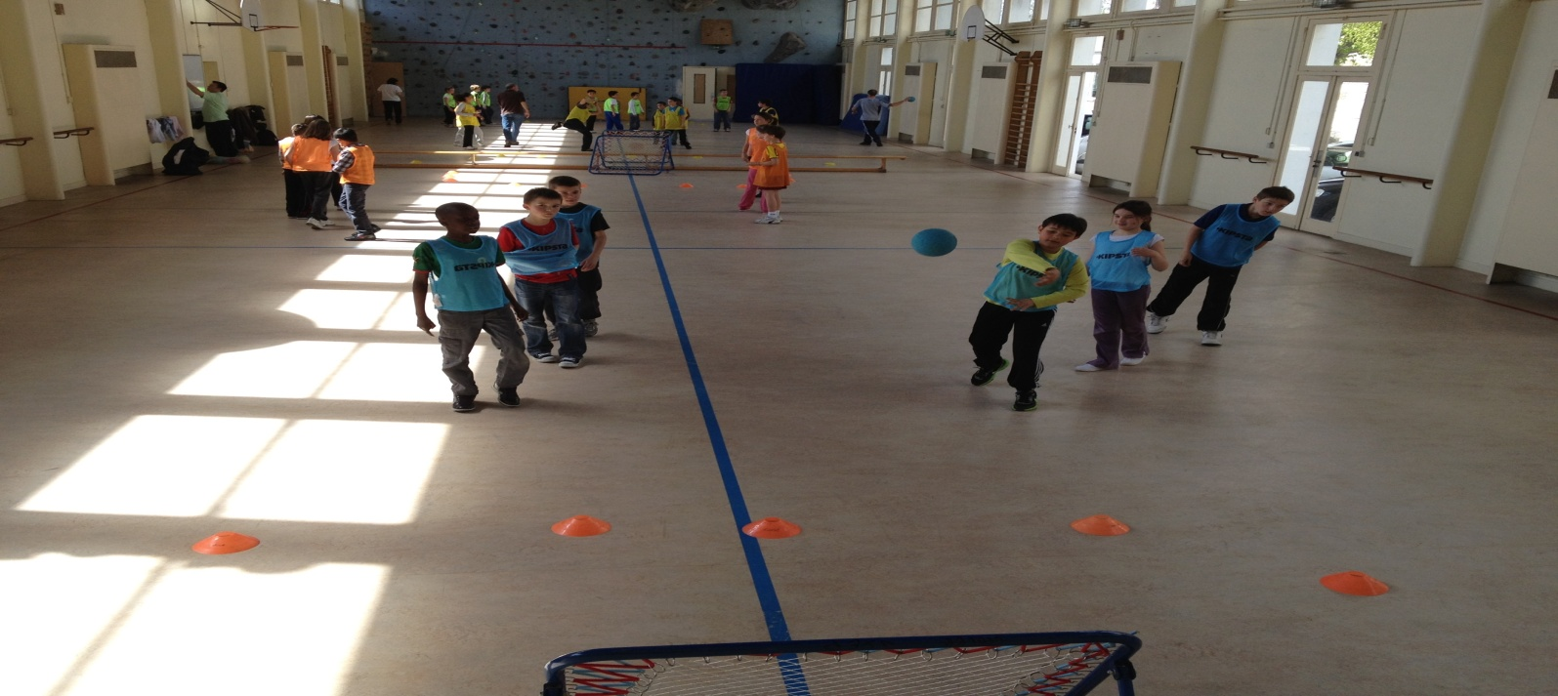

Educational objective : Being able to shoot at target and catch a ball

Organisation : Two teams in two rows in front of a target.
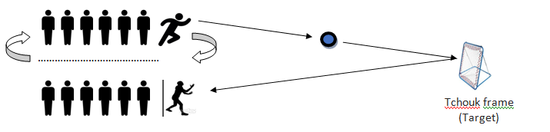

Game rules : The first player in the left column shoots on target. The first player of the other team (right column) must catch it after the rebound, then re-start it and it is to the next one in the right column to catch it, and so on . After shooting, the players go back at the end of the column. The winning team is the one who has caught the most balloons.

Duration of the game : 10 minutes

Equipment : Area delimited, Tchouk frame, and two handballs.

