Hello,
my name is Ada. I’m twelve years old. I’m from Poland. I live in Krobia near Toruń. I’ve got two sisters and often spend time with them. My hobbies are reading books, running and swimming. I can play the piano as well. I haven’t got any pet, but my dream is to have a lovely dog. Playing with animals and caring for them make me feel good. My favourite school subjects are PE and Music.
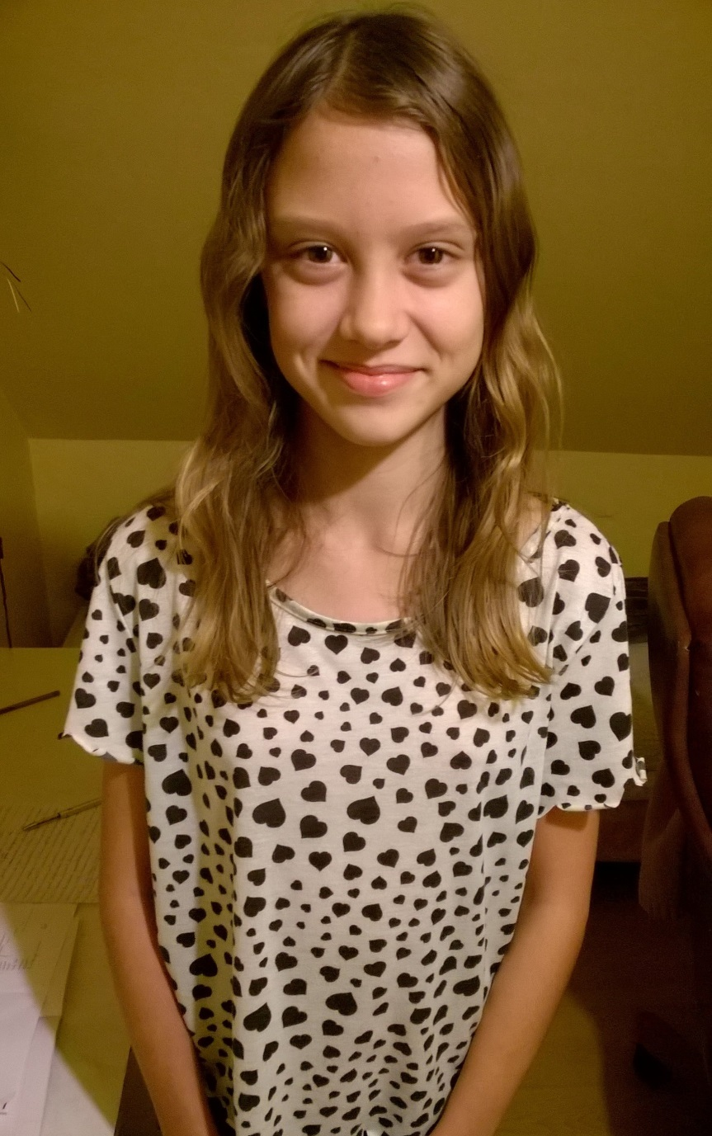
I’m looking forward to visiting Germany .
Best wishes,
Ada Mytlewska

