Hi Felicia, my name is Natalia. I'm 12 years old. I go to 6th grade elementary school. I am very twisted person and I can guarantee that you will not be bored with me. I am a big fan of One Direction. I will bring their Cd so get the CD player ready. One of my favorite activities is singing. I also like to play the piano, drums and guitar. I am loud and fun, but can also be serious and firm. I have a 20-year-old brother, my mom is a teacher and my dad is a soldier. Right now my brother studies in Gdansk (the city situated by the Baltic Sea). I have two dogs: Kiara and Łatka and a cat who has no name. I love to ride horses. It's one of my favorite activities. I can’t wait when we meet. I'm sure that we’ll like each other and spend great a week together. I hope I will not bore you with my stories about 1D
See you later
Natalie
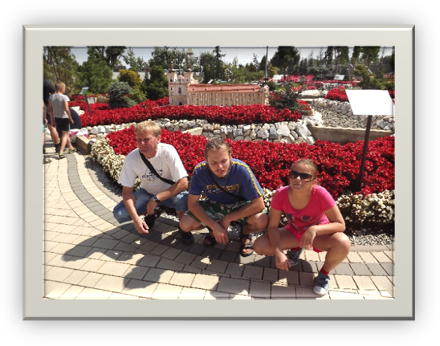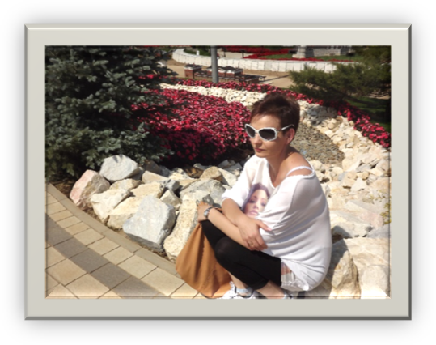
My dad and my brother with me
My mom
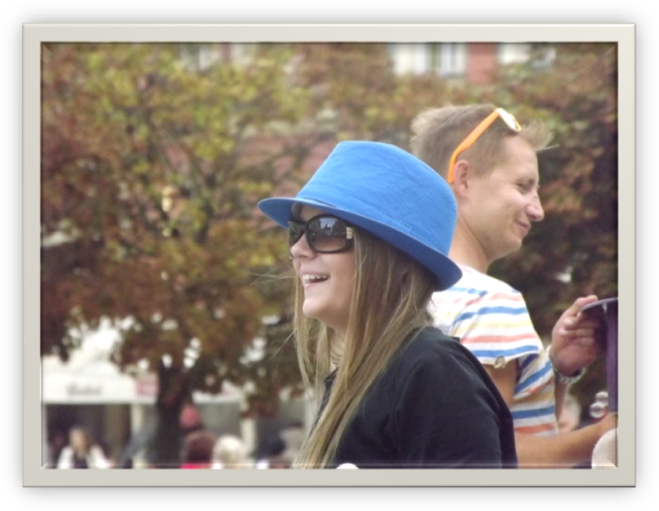
It’s me

